Math 4 Name ________________________
U4 L1 I1 Trigonometric Identities Worksheet

Below are four different categories of problems. The first category is simply your basic identities, possibly rearranged. You NEED to be familiar with these identities and be able to manipulate them. After the identities , there are three sections of problems. The first section are “C” problems. These are problems that you will be expected to be able to complete in order to earn a C on a test or quiz. There is also a section of “B” problems and a section of “A” problems. Try them all – be aware of which section you are working on and your goal for yourself in terms of a grade!

Do your work on another sheet of paper.

Identities
1. 9.

2. 10.

3. 11.

4. 12.

5. 13.

6. 14.

7. 15.

8.

“C” problems

16. 22.

17. 23.

18. 24.

19. 25.

20. 26.

21. 27.
28. 31.

29. 32.

30. 33.

“B” problems

34. 35.

36. 37.

38. 39.

40. 41.

42.

“A” problems

43. 51.

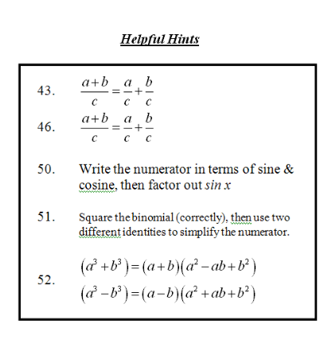
44. 52.

45.

46.

47.

48.

49.

50.

